BROWNIES

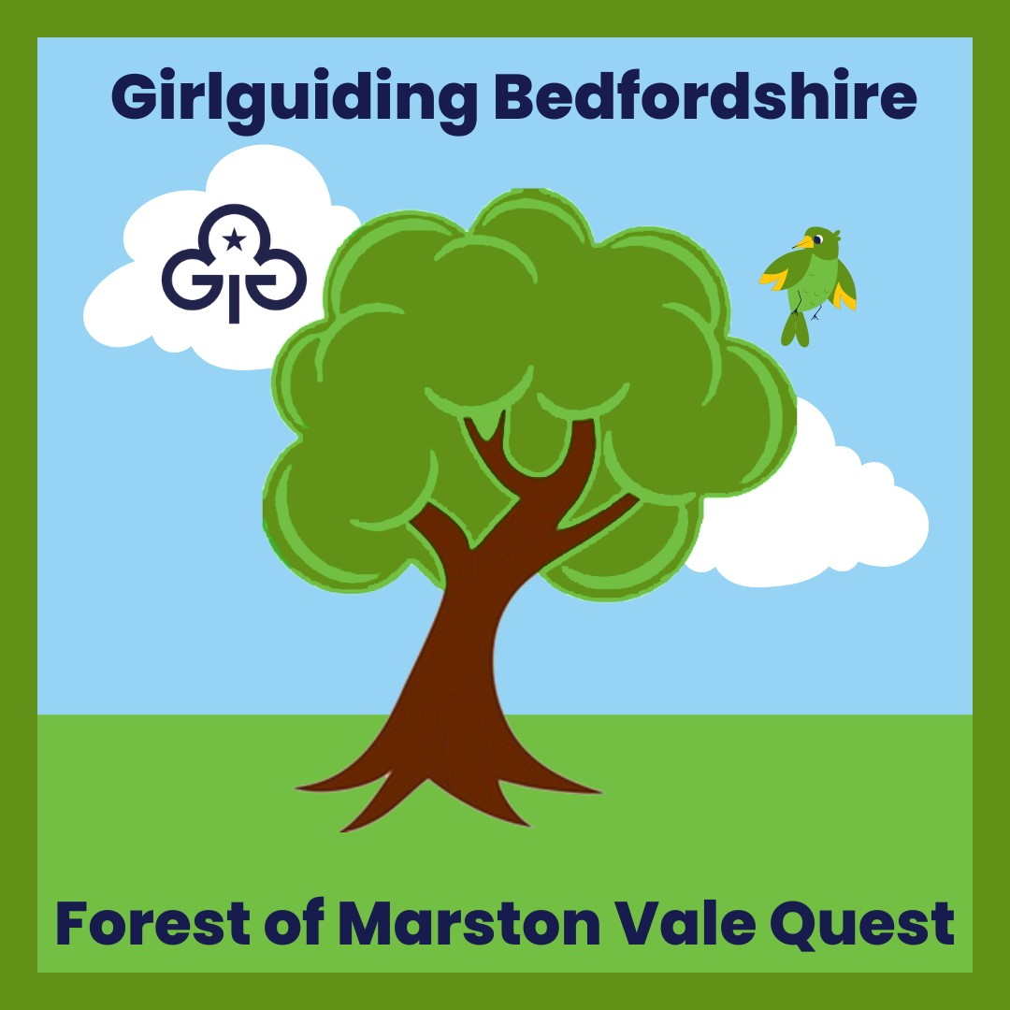

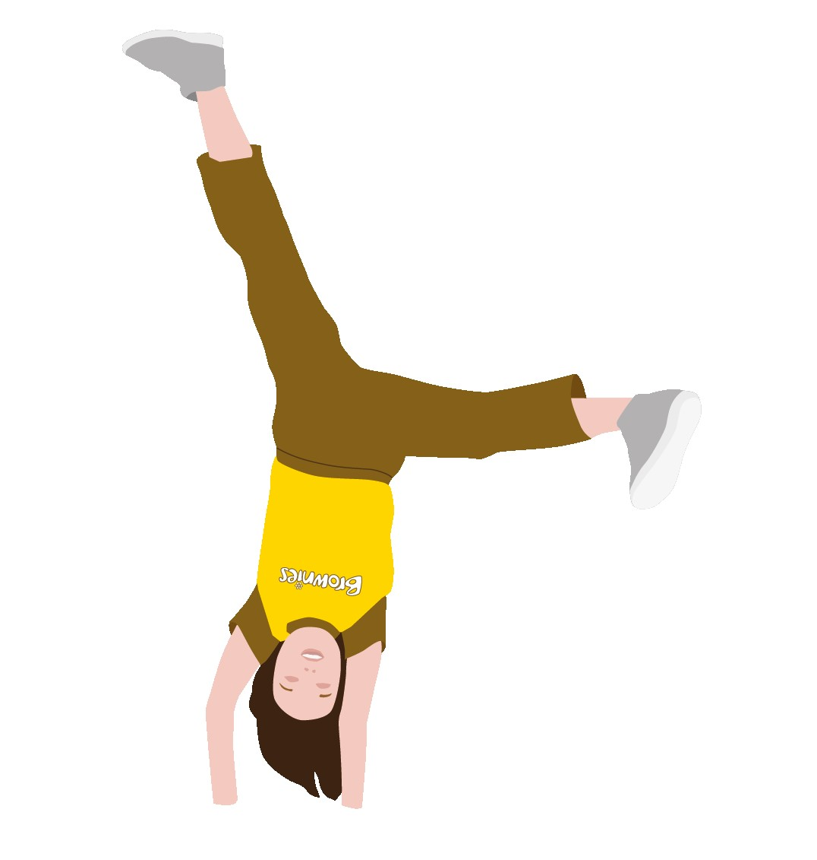

Version 2 July 2023

How to book

There are several ways that you can explore the Millennium Country Park, which is part of the Forest of Marston Vale.

1. Weekend unsupported visits. These are Free. Parking charges apply.

2. Evening or holiday time supported visits.
These cost £4 a child for a half day or evening and £8 for a full day. There is a minimum fee per unit of £60 for half a day or £120 for a full day. If a small unit is wanting to use this option, you may want to link with another unit.
This type of visit will include things like Pond Dipping.

3. The Wetlands Trail, unsupported, around the Nature Reserve. This is where you will find the bird hides, sand martin wall, tower hide and woodland walkway.
Cost - Adults £2.50
Concessions £1.75 (Children 5 to 14 and over 60s)

Badge Order Form

Cost
Badges £2.00
Postage £1.50 (up to 10 badges)
Postage £2.50 (over 10 badges)

Order Details
To order badges please send the following details to events@bedsguiding.org.uk

Unit Name
Contact Name
Contact Address
Number of Badges required
Total Amount paid

Payment Details
Please send payment by bank transfer to
Bedfordshire Guide Association (business account)
Sortcode 301471
Account Number 00929293
Please use code 23-014 and your postcode in the reference field.

If you wish to pay by cheque please post your cheque, with the code 23-014 on the back to:-
Adrian Maynard at 145 Holme Court Avenue, Biggleswade, SG18 8PB
For any other method or questions, please contact events@bedsguiding.org.uk

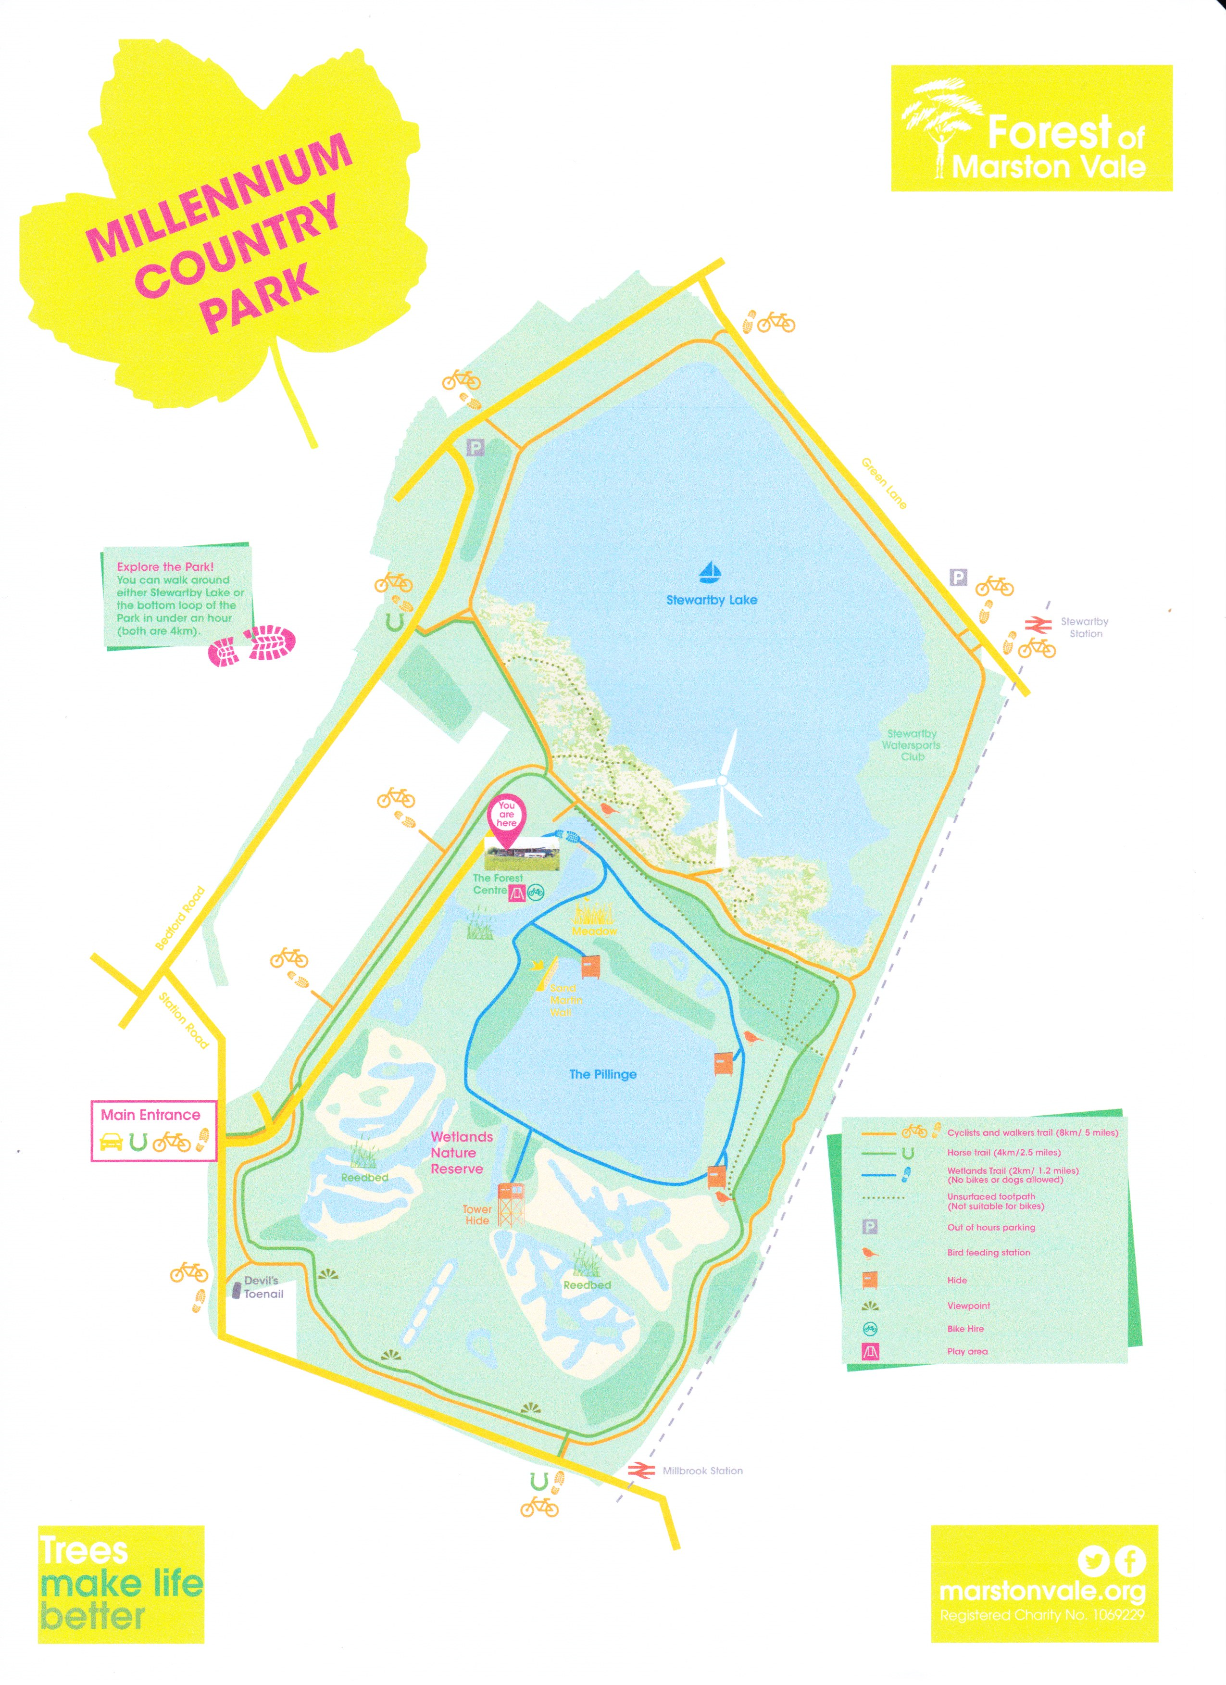

The Forest of Marston Vale Quest- What is it and how does it work for me?
The Forest of Marston Vale is a Community Forest and a charity, planting trees and managing woodlands to make life better for the people and wildlife in the Marston Vale.
The quest has been put together to be a mixture of Forest of Marston Vale activities and Girl guiding skill builders, UMAs and badges.
You can do as much or as little of the pack as works for you in a visit and the pack is flexible and perfect for working with on a one-off visit, or over several visits.
As well as visiting to complete the Quest you have the opportunity to find out more about tree planting activities, fund raising for the Forest and events like pond dipping. Caring for the environment has never been so much fun. There are also activities that you can take back to do in your unit.

Things to see:-
Millennium Country Park is part of the Forest of Marston Vale. Explore the Sensory Wildlife Garden, take a walk over the bridge onto the meadow, fly a kite, explore around the Wetlands Trail (small charge applies) or explore either of the 4km loops around the Park. There is lots to see and do.
We hope you enjoy working on the pack and your time at Millennium Country Park.
Let’s start with a Forest of Marston Vale activity and go on a Scavenger Hunt.
What can you find? Good luck in getting all the boxes filled.
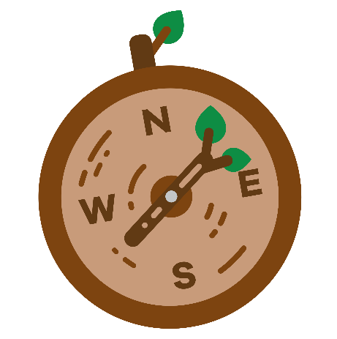

Now you have explored the site, lets have a rest and look at a badge
Have a go at the Mindfulness badge. You will need to complete the challenges and then over the next week, pick one activity from section one or two to do each day. Let your leader know how it went to complete the badge.
1. Senses- Find a relaxing space, take a few slow breaths and ask yourself, what 3 things you can hear, see and feel.
2. Your Own beat- Now time to get moving. Before you start, having sat quietly for a bit, see how your heart is beating. Then do a little dance and see how your heart is beating now.
3. Be grateful- Think of 10 things in your life to be grateful for.

You will find the full details of this badge in your Brownies, “My Badge Book”



Time to explore with another Forest of Marston Vale activity.

Now lets have a look at a UMA.

How about Insect Invaders- The idea is to get into two groups. The first are the Native Ladybirds and the second the Harlequin Ladybirds. Set a box that is the food that the Native Ladybirds want. The Harlequin Ladybirds are between you and the food. You go one at a time to try and get the food. If the Harlequin Ladybirds tag you when you have food, they get your food. If you have no food then you are out.

The UMA card will give you full details of this activity.

Once you have played this game for a bit explore the area. Can you spot any ladybirds? Complete a survey of the area.



Staying with the UMA’s now let look at S.T.O.P

This one looks at the actions to take to deal with a difficult or hazardous situation.

You need to:-
S – Stop and take a breath
T- Think
O- Observe
P – Plan



You will need the UMA card, alongside this pack, to complete this activity.

Time for another Forest of Marston Vale activity

Now let’s explore the skills builders. You will need the skills builders cards alongside this pack to be able to complete these activities.

Explore- A Country Walk
For this skills builder you will need a copy of the Countryside Code. As you wander around , make sure you are following the code.

Explore- Suss out the Symbols
You will need a map so you can look at the different map symbols. First think about the kind of symbols we may use, like river. Draw what you think may be the symbol for 5 items, then compare them to the symbols on the map.
As you walk about look at the things around you and think about how they will be on a map.



Make Change- Environmental Detectives
Your mission is to explore the area hunting for clues that people are harming the environment. Make a note of what you discover and look at what actions are being taken or could be taken to solve the issues



Make Changes- Breaking Down barriers
The aim of this activity is to look at barriers that stop positive change. Set up your obstacle course and see what you can achieve.

The Wetlands Trail is worth taking time to visit. When you buy a ticket you will be given a map which will be your guide to the seasonal wildlife you will find here. Take some quiet time and sit in a hide and see what you can spot.

There are also a range of activities linked to the Forest of Marston Vale that you can do at home or at your meeting place.

Have a go at building a Bug Hotel:

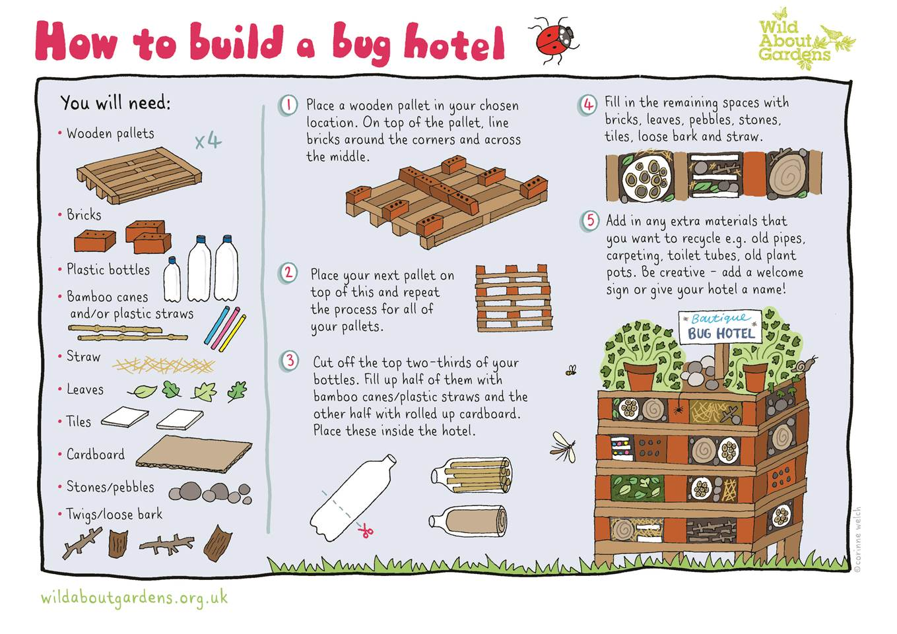

We hope this pack has given you a taste of the things that the Forest of Marston Vale has to offer. Do visit their web page to find out details on the Forest of Marston Vale and the 13 Community Woodlands within the 61 square mile Forest area.

Find more details at:-
www.marstonvale.org

