GUIDES

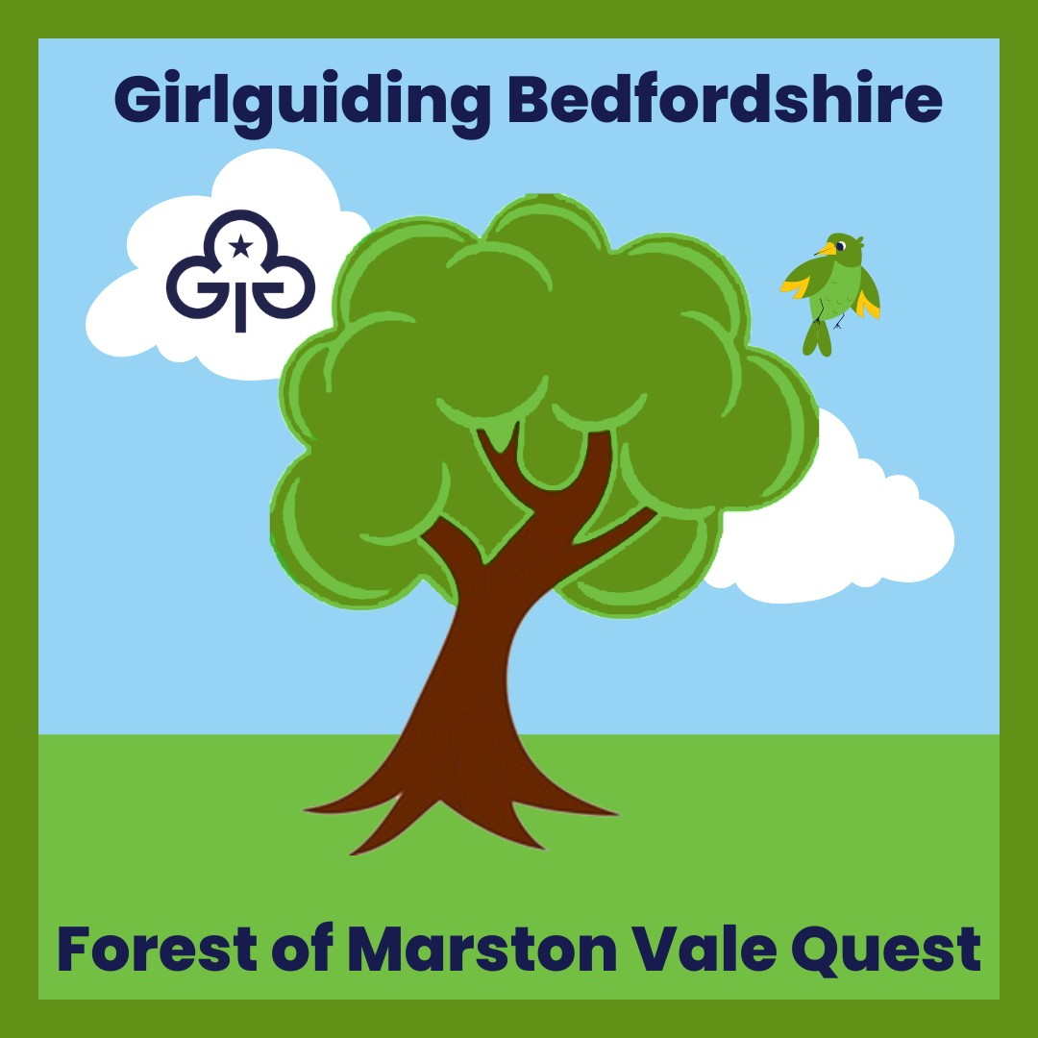



Version 2 July 2023

How to book

There are several ways that you can explore the Millennium Country Park, which is part of the Forest of Marston Vale.

1. Weekend unsupported visits. These are Free. Parking charges apply.

2. Evening or holiday time supported visits.
These cost £4 a child for a half day or evening and £8 for a full day. There is a minimum fee per unit of £60 for half a day or £120 for a full day. If a small unit and wanting to use this option you may want to link with another unit.
This type of visit will include things like Pond Dipping.

3. The Wetlands Trail, unsupported, around the Nature Reserve. This is where you will find the bird hides, sand martin wall , tower hide and woodland walkway.
Cost - Adults £2.50
Concessions £1.75 ( Children 5 to 14 and over 60s)

Badge Order Form

Cost
Badges £2.00
Postage £1.50 (up to 10 badges)
Postage £2.50 (over 10 badges)

Order Details
To order badges please send the following details to events@bedsguiding.org.uk

Unit Name
Contact Name
Contact Address
Number of Badges required
Total Amount paid

Payment Details
Please send payment by bank transfer to
Bedfordshire Guide Association (business account)
Sortcode 301471
Account Number 00929293
Please use code 23-014 and your postcode in the reference field.

If you wish to pay by cheque please post your cheque, with the code 23-014 on the back to:-
Adrian Maynard at 145 Holme Court Avenue, Biggleswade, SG18 8PB
For any other method or questions, please contact events@bedsguiding.org.uk

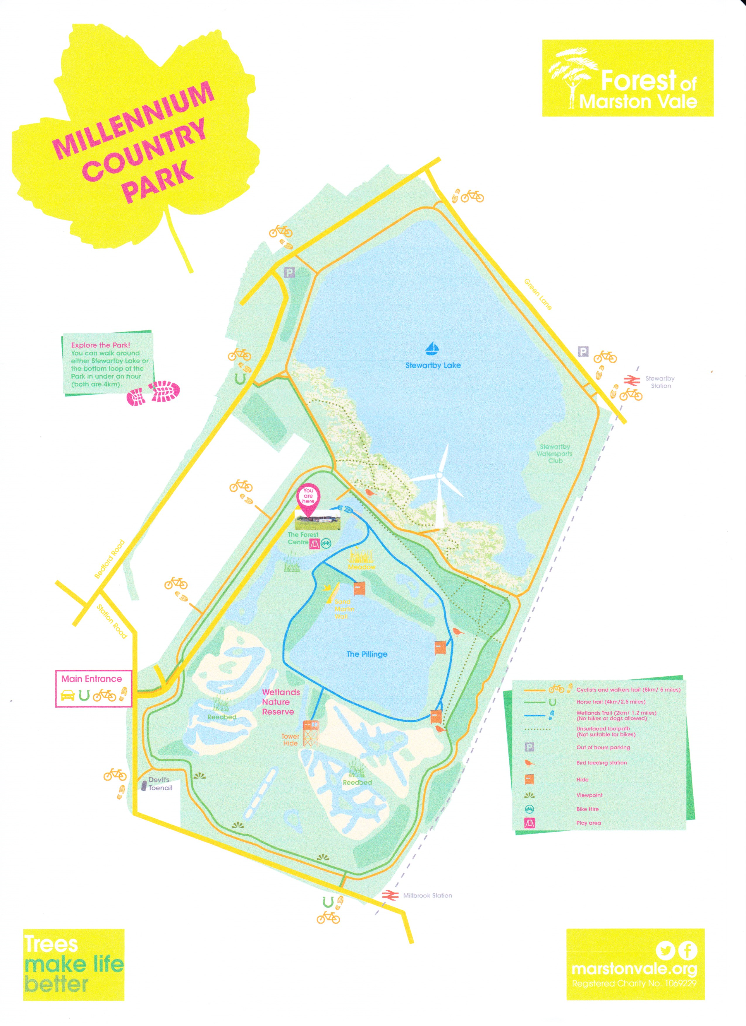

The Forest of Marston Vale Quest- What is it and how does it work for me?
The Forest of Marston Vale is a Community Forest and a charity, planting trees and managing woodlands to make life better for the people and wildlife in the Marston Vale.
The quest has been put together to be a mixture of Forest of Marston Vale activities and Girl guiding skill builders, UMAs and badges.
You can do as much or as little of the pack as works for you in a visit and the pack is flexible and perfect for working with on a one-off visit, or over several visits.
As well as visiting to complete the Quest you have the opportunity to find out more about tree planting activities, fund raising for the Forest and events like Pond dipping. Caring for the environment has never been so much fun. There are also activities that you can take back to do in your unit.
Things to see:-
Millennium Country Park is part of the Forest of Marston Vale. Explore the Sensory Wildlife Garden, take a walk over the bridge onto the meadow, fly a kite, explore around the wetlands trail (small charge applies) or explore either of the 4km loops around the Park. There is lots to see and do.
We hope you enjoy working on the pack and your time at Millennium Country Park.
Let’s start with a Forest of Marston Vale activity and go on a Scavenger Hunt. You can link this to the A -Z in Nature UMA
What can you find? Good luck in getting all the boxes filled.



How about we now have a go at a badge
There are a number you can do while here, buts lets start with the Photography Badge.
Get together in a group and make sure you have at least one camera between you. Look around at the different kind of photos you can take. They maybe landscape or close up of a bug. Try out some different kinds and use the different options on the camera , like zoom.

You can spend some time taking photos. If they are not on your own camera you may need to get them transferred to you so you can finish this badge at home.
At your next meeting, bring in your results to share.

The full details of this badge are in your Guide Badge book.

Another one to try is Meditation. Sit in a quiet spot, close your eyes and be aware of your breathing. It is always good to have time to relax and recharge.
Your badge book will give you full details of the activity.



Lets now try another Forest of Marston Vale activity

Time to now do some work on a UMA
Lets start with having a look at Biodiversity blitz.

You will need a frame which you can make with sticks and string. Find an area and drop your frame on the ground. You now have 20 seconds to list everything you can find inside the frame.
Move the frame to a different area and try again. How many different things can you discover? (remember to take your string home with you or use one of the bins on site)

The full details of this activity can be found on the UMA card.



Looking around the site and sticking with UMA’s , have a look at Carbon Calculator. Find an open space for a break and try this out. Then chat over the results. What can you do to reduce your Carbon Footprint?

Lets have a look at some skills builders. The full details are on the cards and you will need to use them alongside this pack.

Communicate- Signs of the times.
Take a walk and look out for all the different signs you can find. Make a note of what you find, and when you stop for a break, you can talk about these and what they mean and why they are important.



Innovate- Walk of the Town
In pairs go for a walk. One of you points to an object. The other thinks about how they could make this even better and makes a quick sketch. Continue your walk swapping roles. When you stop for a break, share with the group what you have drawn. Are these ideas that could be used in gardens, to improve the park?

Explorer’s Handbook
For this skills builder you are going to document your travels. There are many ways you can do this. It could be in a journal, scrapbook, Vlog, photos. The card will give you full details for this activity.

Explore- G. P. Yes.
Use a GPS Map to explore. Start by looking up 51.498815, -0.143234
Then follow the details on the card.

Explore – Root out the way
For this skill builders you are going to look at how the tress grow, to help you find the way. You will need the skills builders card and pencil and paper. Challenge each other to find the way.

The Wetlands Trail is worth taking time to visit. When you buy a ticket, you will be given a map which will be your guide to the seasonal wildlife you will find here. Take some quiet time and sit in a hide and see what you can spot.

There are also a range of activities linked to the Forest of Marston Vale that you can do at home or at your meeting place.

Have a go at building a Bug Hotel:

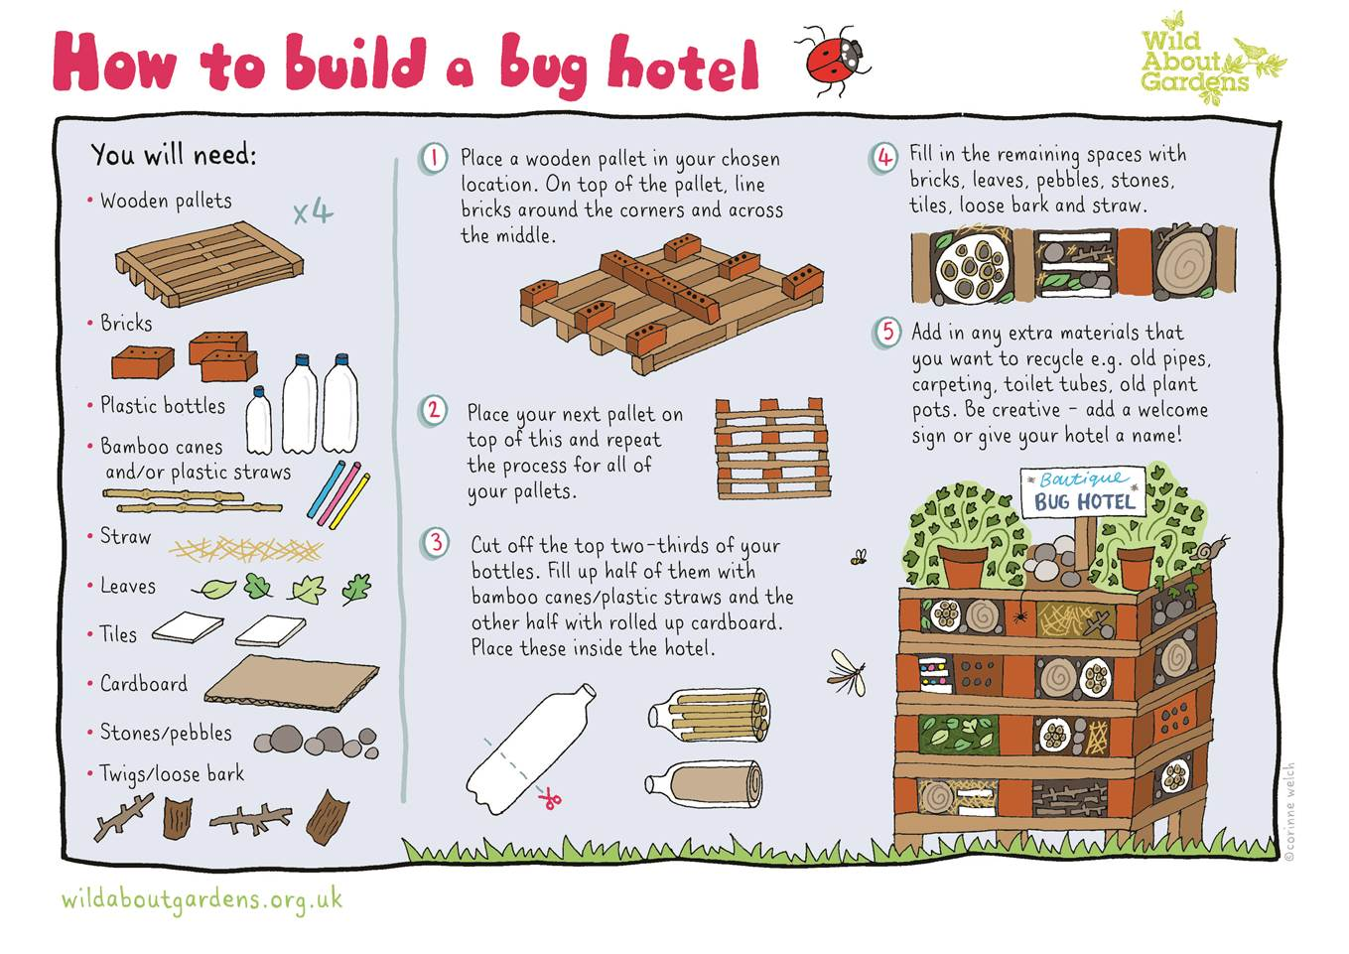

We hope this pack has given you a taste of the things that the Forest of Marston Vale has to offer. Do visit their web page to find out details on the Forest of Marston Vale and the 13 Community Woodlands within the 61 square mile Forest area.

Find more details at:-
www.marstonvale.org

