
Bedfordshire County International Opportunities Selection Day
Saturday 25th March

The Selection Day will be held at Wrest Park, Silsoe, Bedfordshire MK45 4HR from 11:00am – 4:00pm the cost for the day is FREE.

If you have young members aged 11+ that would like to represent Bedfordshire and Girlguiding on an International Opportunity, then this is the place to start their journey.

The day will be filled with fun activities and challenges to identify girls to put forward to the Region selection.

The selection day does not guarantee a place, if they are successful then they will be representing Bedfordshire County at the Region selection process.

If they are successful at Region selection, they will be invited to attend an International Event.

Planning is in process for a trip in 2025 to one of the Girlguiding World Centres either Sangam in India or Our Cabana in Mexico. The cost of this trip is to be self-funded and as an indication the cost is estimated at £2,500.

If you have a young member that would like to take part in the selection day, please can they complete the attached application form and return by Sunday 12th March to international@bedsguiding.org.uk

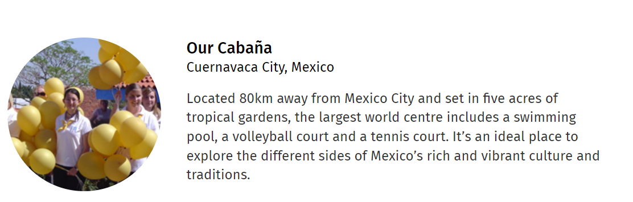
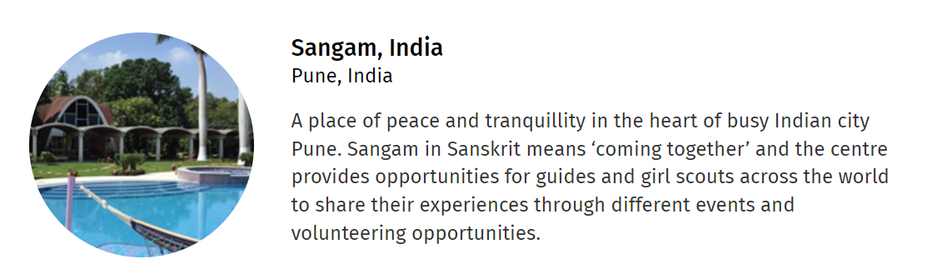

Zita - County International Adviser

