
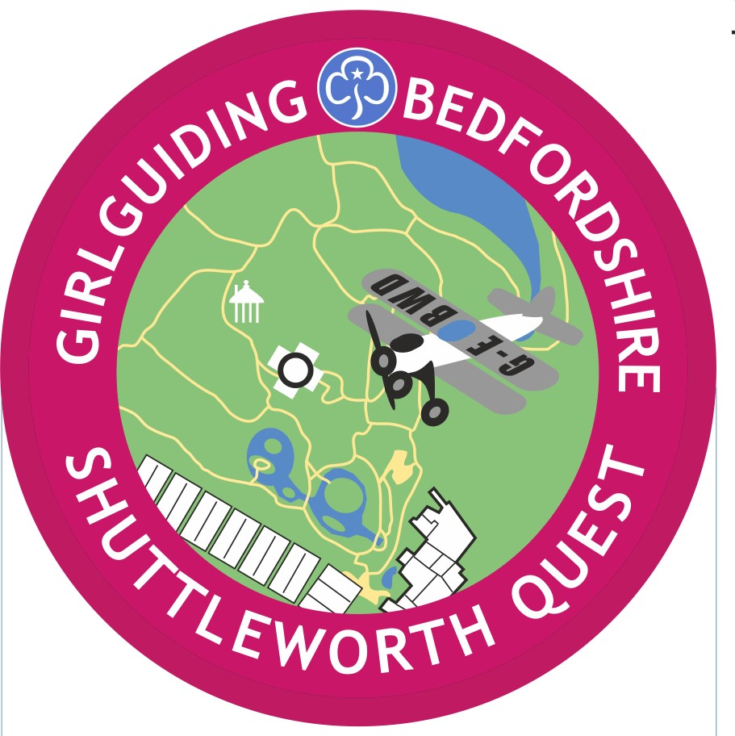
BOOKING FORM

The Girlguiding Bedfordshire Shuttleworth Challenge
Our educational programmes compliment the learning objectives as set out in the National Curriculum and we can offer bespoke packages to suit your individual needs.
The Shuttleworth Discovery App - www.shuttleworth.org/discovery
We have introduced a mobile technology educational resource called the Shuttleworth Discovery App. Please feel free to access this resource and download the application whilst on site. Wi-fi is free to all visitors and the access code can be found at the reception kiosk in the shop foyer.
YOUR DETAILS
Date of visit
Group

Address

Post Code
Leader in Charge

Leader mobile no.

Leader email

YOUR GROUP DETAILS
No. of Students
Age of Students
Covid19 - Please detail the ‘bubbles’ in your group

No. of Accompanying Adults
YOUR VISIT
Estimated Arrival Time
Eating Time
Estimated Departure Time
STUDENTS WITH SPECIAL NEEDS IN YOUR GROUP
(Staff supporting pupils with special needs will be admitted free on a one per one basis)
No. of children with special needs
Do you require a wheelchair?
Please describe any other requirements that will help your visit with us

PLEASE TURN OVER TO THE OTHER SIDE

SHUTTLEWORTH
How did you find out about us?

Would you like your girls to: (delete as appropriate)
have time in our shop / have goodie bags to value of £ . p each / avoid the shop
PLEASE READ AND SIGN BELOW I have read and understood the following requirements
- The ratio of adults to children for purposes of supervision must be at least 1:10
- Adults should remain in the same hangar building as the students that are in their charge. Adults must be in supervision when students are in the café, shop, playground, Swiss Garden and airfield site.
- In case of an emergency and a member of staff needs to contact your party during your visit, we will require a mobile telephone number.
- We would ask that for both self-directed and guided visits to Shuttleworth, that all parties respect the environment that they are in and appreciate that there will be members of the public on site as well.
- No eating or drinking is allowed in the hangars. Shuttleworth is unique in that nearly all of the exhibits are in, or are in the process of being made to be, in working order. We would ask all visitors to respect the barriers that cordon of the exhibits, which are there to protect both the visitors and our wonderful collection.
- Filming of educational sessions is not permitted. Photography by the students is of course permitted. Please ask the session leader for confirmation on anything that you are not sure about.
- Shuttleworth is an active airfield, the health and safety of our visitors is paramount. Please ensure that all airfield barriers are respected. Litter is very dangerous to aircraft, please ensure that it is disposed of correctly.
- For security reasons, please do not leave bags unattended. Educational parties will be allocated an area where their belongings can be kept.
- The above requirements are to ensure the safety and enjoyment of all visitors to Shuttleworth. Failure to adhere to these requirements may mean that we would regretfully ask your party to leave the site.
Preliminary visits (Up to 2 members of staff are welcome for a preliminary visit)
Date of preliminary visit:
Names of staff attending free preliminary visit:

Signature of leader
Name of group
Date
GDPR: We hope your booking will be the start of a long and productive association with Shuttleworth. Accordingly, we would like to be able to keep you informed of relevant learning opportunities. Your contact details will not be used by any other department or passed to any third party. Please tick if you would not like your details to be added to our schools database.
Please return this form to: School Visits
The Shuttleworth Trust | Old Warden Aerodrome | Biggleswade | Beds | SG18 9EP
Tel: 01767 627 934 | learning@shuttleworth.org | www.shuttleworth.org

